Name

Mathematics Stage 5 Paths
Fractional Indices

Book 1 |  | Version: 261007  Feedback:  https://MrDingMaths.com
Contents
Syllabus Content 2
Learning Intention 3

Syllabus Content
MA5-IND-P-02 describes and performs operations with surds and fractional indices
Describe and use fractional indices
- Apply index laws to describe fractional indices as: $a^{\frac{1}{n}}=\sqrt[n]{a}$ and${ a}^{\frac{m}{n}}=\sqrt[n]{a^{m}}={\left(\sqrt[n]{a}\right)}^{m}$
- Translate expressions in surd form to expressions in index form and vice versa
- Evaluate numerical expressions involving fractional indices including using digital tools

Learning Intention

- Fractional Indices
  - Use the index laws to simplify ${\left(a^{\frac{1}{2}}\right)}^{2}$
  - Simplify ${\left(\sqrt{a}\right)}^{2}$
  - Therefore, what can you conclude about $a^{\frac{1}{2}}$ and $\sqrt{a}$?

  - Use the index laws to simplify ${\left(a^{\frac{1}{3}}\right)}^{3}$
  - Simplify ${\left(\sqrt[3]{a}\right)}^{3}$
  - Therefore, what can you conclude about $a^{\frac{1}{3}}$ and $\sqrt[3]{a}$?

- Fractional Indices
For a fractional index, the denominator is the index of the surd.
$$a^{\frac{1}{2}}=\sqrt{a} \\ a^{\frac{1}{3}}=\sqrt[3]{a}$$
$$a^{\frac{1}{n}}=\sqrt[n]{a}$$

- Convert between index form and surd form
$$7^{\frac{1}{2}}$$  $=\sqrt{7}$ |  | ${10}^{\frac{1}{2}}$  $=\sqrt{10}$ |  | ${10}^{\frac{1}{3}}$  $=\sqrt[3]{10}$
Express these numbers in surd form.
- $m^{\frac{1}{2}}$ | - $y^{\frac{1}{4}}$ |  | - $p^{\frac{1}{3}}$ |  | - ${62}^{\frac{1}{n}}$
- ${49}^{\frac{1}{2}}$ | - ${11}^{0.5}$ |  | - ${25}^{0.5}$ |  | - $z^{\frac{1}{x}}$
Express these numbers in index form.
- $\sqrt{10}$ | - $\sqrt[3]{7}$ |  | - $\sqrt[5]{k}$ |  | - $\sqrt[n]{x}$
- $\sqrt[3]{y}$ | - $\sqrt[4]{z}$ |  | - $\sqrt[n]{5}$ |  | - $\sqrt{5}$

- Key Ideas
- Since $a^{\frac{1}{2}}×a^{\frac{1}{2}}=a$, we can conclude that $a^{\frac{1}{2}}$ is the same as ……………………
- Since $a^{\frac{1}{3}}×a^{\frac{1}{3}}×a^{\frac{1}{3}}=a$, we can conclude that $a^{\frac{1}{3}}$ is the same as ……………………
- In general, we can convert between surd form and fractional form using the rule ……$=\sqrt[n]{x}$

Foundation
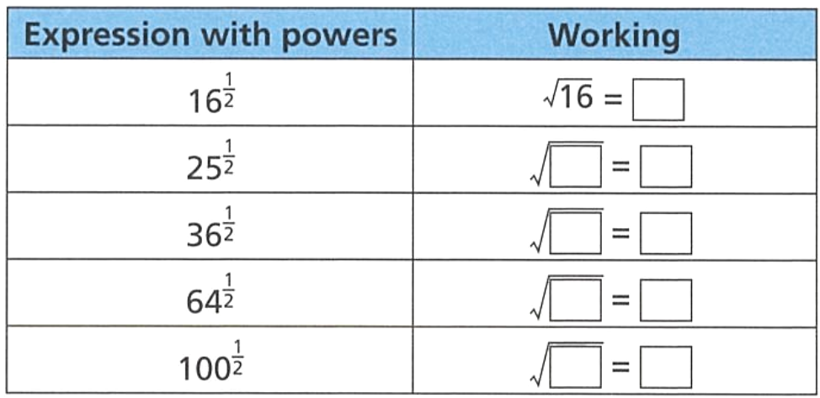
- Complete the table to evaluate these fractional indices.

4
$$\sqrt{25}=5$$
$$\sqrt{36}=6$$
$$\sqrt{64}=8$$
$$\sqrt{100}=10$$

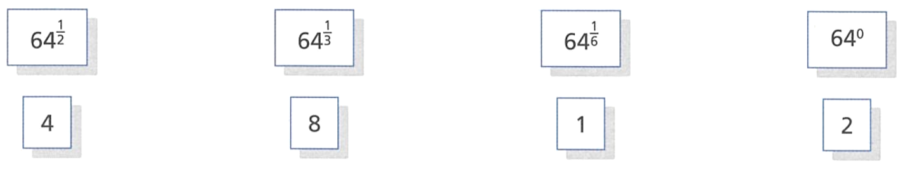
- Match each expression with a power to its correct value.

$${64}^{\frac{1}{2}}=8, {64}^{\frac{1}{3}}=4, {64}^{\frac{1}{6}}=2, {64}^{0}=1$$
- Complete the table.
Index Form | As a root | Decimal | Surd? (yes or no)
$$2^{\frac{1}{2}}$$ | $$\sqrt{2}$$ | 1.414213562… | yes
$$4^{\frac{1}{2}}$$ | $$\sqrt{4}$$ | 2 | No
$${11}^{\frac{1}{2}}$$ | $$\sqrt{11}$$ | 3.31662479… | Yes
$${36}^{\frac{1}{2}}$$ | $$\sqrt{36}$$ | 6 | No
$${\left(\frac{1}{9}\right)}^{\frac{1}{2}}$$ | $$\sqrt{\frac{1}{9}}$$ | $$0.\dot{3}$$ | No
$${\left(0.1\right)}^{\frac{1}{2}}$$ | $$\sqrt{0.1}$$ | 0.316227766… | Yes
$$3^{\frac{1}{3}}$$ | $$\sqrt[3]{3}$$ | 1.44224957 | Yes
$$8^{\frac{1}{3}}$$ | $$\sqrt[3]{8}$$ | 2 | No
$${15}^{\frac{1}{3}}$$ | $$\sqrt[3]{15}$$ | 2.466212074… | Yes
$${\left(\frac{1}{27}\right)}^{\frac{1}{3}}$$ | $$\sqrt[3]{\frac{1}{27}}$$ | $$0.\dot{3}$$ | No
$$5^{\frac{1}{4}}$$ | $$\sqrt[4]{5}$$ | 1.495348781… | Yes

- Write these numbers as a root.
- $3^{\frac{1}{2}}$  $$\sqrt{3}$$ | - $7^{\frac{1}{2}}$  $$\sqrt{7}$$ | - $5^{\frac{1}{3}}$  $$\sqrt[3]{5}$$ | - ${12}^{\frac{1}{3}}$  $$\sqrt[3]{12}$$
- ${31}^{\frac{1}{5}}$  $$\sqrt[5]{31}$$ | - ${18}^{\frac{1}{7}}$  $$\sqrt[7]{18}$$ | - $9^{\frac{1}{10}}$  $$\sqrt[10]{9}$$ | - ${324}^{\frac{1}{8}}$  $$\sqrt[8]{324}$$

- Write these numbers in index form.
- $\sqrt{8}$  $$8^{\frac{1}{2}}$$ | - $\sqrt{19}$  $${19}^{\frac{1}{2}}$$ | - $\sqrt[3]{10}$  $${10}^{\frac{1}{3}}$$ | - $\sqrt[3]{31}$  $${31}^{\frac{1}{3}}$$
- $\sqrt[4]{5}$  $$5^{\frac{1}{4}}$$ | - $\sqrt[5]{95}$  $${95}^{\frac{1}{5}}$$ | - $\sqrt[8]{111}$  $${111}^{\frac{1}{8}}$$ | - $\sqrt[524]{20}$  $${20}^{\frac{1}{524}}$$

- Evaluate these numbers, rounding to 2 d.p. where necessary.
- $4^{\frac{1}{2}}$ and $\sqrt{4}$  2 | - $8^{\frac{1}{3}}$ and $\sqrt[3]{8}$  2 | - $9^{0.5}$ and $\sqrt{9}$  3
- ${12}^{\frac{1}{2}}$ and $\sqrt{12}$  3.46 | - $\sqrt[3]{1000}$ and ${1000}^{\frac{1}{3}}$  10 | - $\sqrt[5]{32}$ and ${32}^{\frac{1}{5}}$  2

- Evaluate these numbers, leaving your answer as a whole number.
- ${25}^{\frac{1}{2}}$  5 | - ${49}^{\frac{1}{2}}$  7 | - ${81}^{\frac{1}{2}}$  9 | - ${169}^{\frac{1}{2}}$  13
- $8^{\frac{1}{3}}$  2 | - ${64}^{\frac{1}{3}}$  4 | - ${125}^{\frac{1}{3}}$  5 | - ${1000}^{\frac{1}{3}}$  10
- ${16}^{\frac{1}{4}}$  2 | - ${81}^{\frac{1}{4}}$  3 | - ${625}^{\frac{1}{4}}$  5 | - ${32}^{\frac{1}{5}}$  2

- Work out the missing powers,
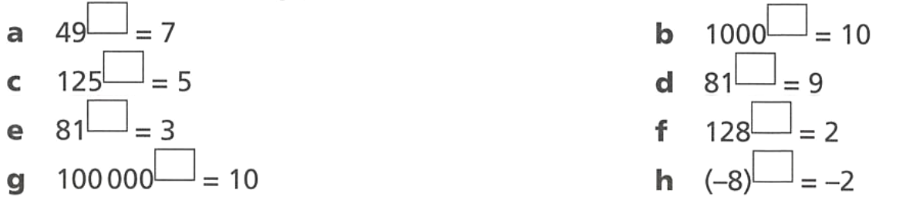  $$\frac{1}{2}$$ | $$\frac{1}{3}$$ | $$\frac{1}{4}$$ | $$\frac{1}{5}$$
$$\frac{1}{3}$$ | $$\frac{1}{2}$$ | $$\frac{1}{7}$$ | $$\frac{1}{3}$$

- Explain why it is not possible to evaluate ${\left(-9\right)}^{\frac{1}{2}}$

This is $\sqrt{-9}$, it is not possible to evaluate the square root of a negative (yet)

Development
- State whether these statements are true or false.
- $\sqrt[3]{8}=8^{\frac{1}{3}}$  T | - $\sqrt{3}=3^{0.5}$  T | - $5^{\frac{1}{3}}=\sqrt{5}$  F | - ${10}^{\frac{1}{6}}=\sqrt[10]{6}$  F
- $8^{\frac{1}{2}}=4$  F | - ${16}^{\frac{1}{2}}=4$  T | - ${27}^{\frac{1}{3}}=9$  F | - ${100}^{0.5}=10$  T

- Evaluate these expressions.
2 | 2 | 2 | 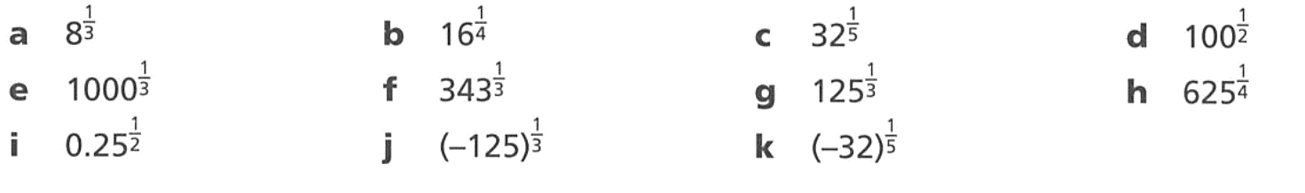  10
10 | 7 | 5 | 5
0.5 | $$-5$$ | $$-2$$

- Evaluate these without a calculator. First rewrite each question using positive indices.
- $4^{-\frac{1}{2}}={\left(\frac{1}{4}\right)}^{\frac{1}{2}}$  $$=\frac{1^{\frac{1}{2}}}{4^{\frac{1}{2}}}$$  $=$ ………  $$\frac{1}{2}$$ | - $8^{-\frac{1}{3}}$  $$\frac{1}{2}$$ | - ${32}^{-\frac{1}{5}}$  $$\frac{1}{2}$$ | - ${81}^{-\frac{1}{4}}$  $$\frac{1}{3}$$
- ${25}^{-\frac{1}{2}}$  $$\frac{1}{5}$$ | - ${27}^{-\frac{1}{3}}$  $$\frac{1}{3}$$ | - ${1000}^{-\frac{1}{3}}$  $$\frac{1}{10}$$ | - ${256}^{-\frac{1}{4}}$  $$\frac{1}{4}$$

- Use index laws to simplify these expressions. Leave your answer in index form.
$$a$$ | $$a^{\frac{2}{3}}$$ | 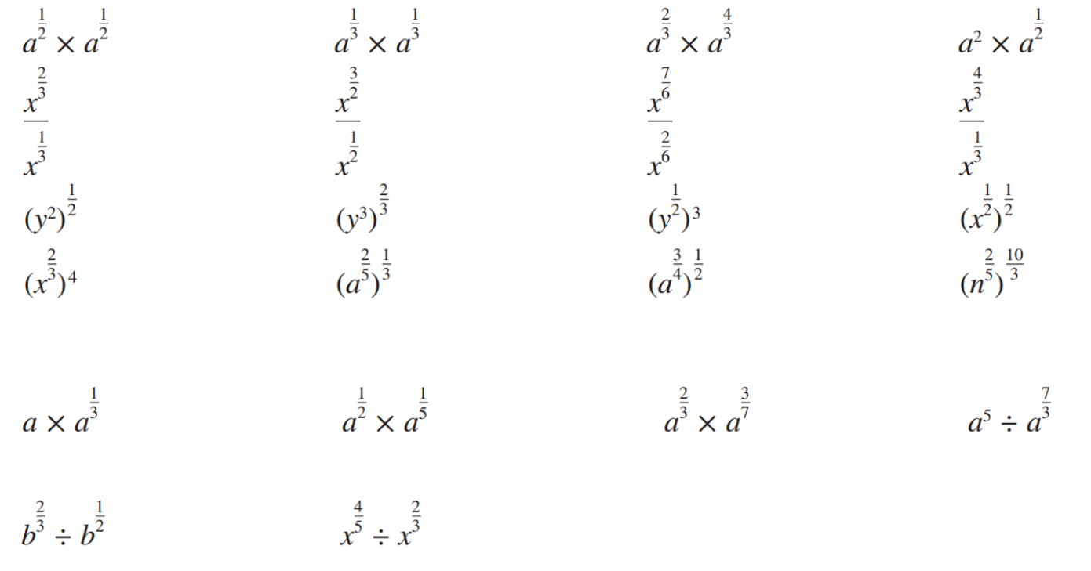  $$a^{2}$$ | $$a^{\frac{5}{2}}$$
$$x^{\frac{1}{3}}$$ | $$x$$ | $$x^{\frac{5}{6}}$$ | $$x$$
$$y$$ | $$y^{2}$$ | $$y^{\frac{3}{2}}$$ | $$x^{\frac{1}{4}}$$
$$x^{\frac{8}{3}}$$ | $$a^{\frac{2}{15}}$$ | $$a^{\frac{3}{8}}$$ | $$n^{\frac{4}{3}}$$
$$a^{\frac{4}{3}}$$ | $$a^{\frac{7}{10}}$$ | $$a^{\frac{23}{21}}$$ | $$a^{\frac{8}{3}}$$

- Simplify the following.
- $a^{\frac{1}{2}}×a^{-\frac{1}{2}}$  1 | - $a^{\frac{2}{3}}×a^{-\frac{2}{3}}$  $$1$$ | - $a^{\frac{4}{7}}×a^{-\frac{4}{7}}$  1
- $a^{\frac{5}{6}}÷a^{\frac{5}{6}}$  $$1$$ | - ${\left(a^{\frac{1}{2}}\right)}^{\frac{1}{2}}÷a^{\frac{1}{4}}$  $$1$$ | - $a^{2}÷{\left(a^{3}\right)}^{\frac{2}{3}}$  $$1$$

What do you notice about your answers?

They all evaluate to 1

Mastery
- Evaluate without a calculator.
- ${36}^{\frac{1}{2}}$  6 | - ${27}^{\frac{1}{3}}$  3 | - ${64}^{\frac{1}{3}}$  4
- ${49}^{\frac{1}{2}}$  7 | - ${16}^{\frac{1}{4}}$  2 | - ${125}^{\frac{1}{3}}$  5
- $9^{-\frac{1}{2}}$  $$\frac{1}{3}$$ | - ${32}^{-\frac{1}{5}}$  $$\frac{1}{2}$$ | - ${81}^{-\frac{1}{4}}$  $$\frac{1}{3}$$
- ${1000}^{-\frac{1}{3}}$  $$\frac{1}{10}$$ | - ${400}^{-\frac{1}{2}}$  $$\frac{1}{20}$$ | - ${10000}^{-\frac{1}{4}}$  $$\frac{1}{10}$$

- Use the fact that ${\left(\frac{4}{9}\right)}^{\frac{1}{2}}=\sqrt{\frac{4}{9}}=\frac{2}{3}$ to evaluate the following:
- ${\left(\frac{16}{25}\right)}^{\frac{1}{2}}$  $$\frac{4}{5}$$ | - ${\left(\frac{9}{49}\right)}^{\frac{1}{2}}$  $$\frac{3}{7}$$ | - ${\left(\frac{4}{81}\right)}^{\frac{1}{2}}$  $$\frac{2}{9}$$ | - ${\left(\frac{8}{27}\right)}^{\frac{1}{3}}$  $$\frac{2}{3}$$
- ${\left(\frac{64}{125}\right)}^{\frac{1}{3}}$  $$\frac{4}{5}$$ | - ${\left(\frac{16}{81}\right)}^{\frac{1}{4}}$  $$\frac{2}{3}$$ | - ${\left(\frac{256}{625}\right)}^{\frac{1}{4}}$  $$\frac{4}{5}$$ | - ${\left(\frac{1000}{343}\right)}^{\frac{1}{3}}$  $$\frac{10}{7}$$

- Use the fact that ${\left(\frac{4}{9}\right)}^{-\frac{1}{2}}={\left(\frac{9}{4}\right)}^{\frac{1}{2}}=\sqrt{\frac{9}{4}}=\frac{3}{2}$ to evaluate the following:
- ${\left(\frac{9}{4}\right)}^{-\frac{1}{2}}$  $$\frac{2}{3}$$ | - ${\left(\frac{49}{144}\right)}^{-\frac{1}{2}}$  $$\frac{12}{7}$$ | - ${\left(\frac{8}{125}\right)}^{-\frac{1}{3}}$  $$\frac{5}{2}$$ | - ${\left(\frac{1296}{625}\right)}^{-\frac{1}{4}}$  $$\frac{5}{6}$$

Further Fractional Indices

- Fractional Indices
- The denominator is the index of the surd.
- The numerator is the power.
$$a^{\frac{m}{n}}=\sqrt[n]{a^{m}}={\left(\sqrt[n]{a}\right)}^{m}$$

- Example Convert expressions in index form to surds
$x^{\frac{2}{3}}$  $$=\sqrt[3]{x^{2}}$$ | $$x^{\frac{5}{7}}$$  $$=\sqrt[7]{x^{5}}$$ | $$x^{-\frac{5}{7}}$$  $$=\frac{1}{\sqrt[7]{x^{5}}}$$

- Guided Practice
Express in surd form.
- $x^{\frac{2}{5}}$ | - $x^{\frac{5}{2}}$ | - $y^{\frac{2}{7}}$
- $9^{-\frac{3}{2}}$ | - $y^{-\frac{2}{3}}$ | - $\frac{a}{b^{\frac{3}{2}}}$

- Example Convert expressions in surd form to index form
$\sqrt[3]{a^{2}}$  $$=a^{\frac{2}{3}}$$ | $$a\sqrt{a^{3}}$$  $$=a×a^{\frac{3}{2}}$$  $$=a^{\frac{5}{2}}$$ | $$\frac{y}{\sqrt[4]{x^{7}}}$$  $$=yx^{-\frac{7}{4}}$$

- Guided Practice
Express in index form.
- $\sqrt{x^{3}}$ | - $\sqrt[5]{x^{2}}$ | - $\sqrt{2a}$
- $x\sqrt{x^{5}}$ | - $y \sqrt[3]{x^{2}}$ | - $\frac{1}{\sqrt[3]{y^{2}}}$

Foundation
- Write the following with fractional indices.
- $\sqrt{8}$  $$8^{\frac{1}{2}}$$ | - $\sqrt[3]{7}$  $$7^{\frac{1}{3}}$$ | - $\sqrt[5]{10}$  $${10}^{\frac{1}{5}}$$
- $\sqrt[13]{100}$  $${100}^{\frac{1}{13}}$$ | - $\sqrt[3]{5}$  $$5^{\frac{1}{3}}$$ | - $\sqrt{5}$  $$5^{\frac{1}{2}}$$
- $\sqrt{29}$  $${29}^{\frac{1}{2}}$$ | - $\sqrt[3]{35}$  $${35}^{\frac{1}{3}}$$ | - $\sqrt[5]{x^{2}}$  $$x^{\frac{2}{5}}$$
- ${\left(\sqrt{m}\right)}^{5}$  $$m^{\frac{5}{2}}$$ | - $\sqrt{m^{5}}$  $$m^{\frac{5}{2}}$$ | - ${\left(\sqrt{a}\right)}^{5}$  $$a^{\frac{5}{2}}$$
- $\sqrt[4]{{10}^{3}}$  $${10}^{\frac{3}{4}}$$ | - ${\left(\sqrt[4]{10}\right)}^{3}$  $${10}^{\frac{3}{4}}$$ | - ${\left(\sqrt[7]{x}\right)}^{n}$  $$x^{\frac{n}{7}}$$
- $\sqrt[4]{b^{3}}$  $$b^{\frac{3}{4}}$$ | - $\sqrt{a}$  $$a^{\frac{1}{2}}$$ | - $\sqrt[3]{t^{2}}$  $$t^{\frac{2}{3}}$$

- Express the following in surd form.
- $2^{\frac{1}{5}}$  $$\sqrt[5]{2}$$ | - $8^{\frac{1}{7}}$  $$\sqrt[7]{8}$$ | - $6^{\frac{1}{3}}$  $$\sqrt[3]{6}$$
- $3^{\frac{3}{2}}$  $$\sqrt[2]{3^{3}}$$ | - $7^{\frac{2}{3}}$  $$\sqrt[3]{7^{2}}$$ | - $2^{\frac{3}{5}}$  $$\sqrt[5]{2^{3}}$$
- ${25}^{\frac{3}{4}}$  $$\sqrt[4]{{25}^{3}}$$ | - $x^{\frac{n}{5}}$  $$\sqrt[5]{x^{n}}$$ | - $x^{\frac{5}{n}}$  $$\sqrt[n]{x^{5}}$$

- Look at the examples below for evaluating ${16}^{\frac{5}{4}}$
Method 1  $${16}^{\frac{5}{4}}={\left({16}^{5}\right)}^{\frac{1}{4}} \\ ={\left(1 048 576\right)}^{\frac{1}{4}} \\ =\sqrt[4]{1 048 576} \\ =32$$ | Method 2  $${16}^{\frac{5}{4}}={\left({16}^{\frac{1}{4}}\right)}^{5} \\ ={\left(\sqrt[4]{16}\right)}^{5} \\ =2^{5}$$  $=32$
Why is method 2, rooting before raising to the power, easier?

You work with smaller numbers.

Development
- Evaluate the following without a calculator.
- ${27}^{\frac{2}{3}}$  9 | - ${64}^{\frac{2}{3}}$  16 | - $9^{\frac{3}{2}}$  27
- ${16}^{\frac{5}{4}}$  32 | - $4^{\frac{5}{2}}$  32 | - ${81}^{\frac{3}{2}}$  729
- ${\left(\frac{1}{9}\right)}^{\frac{3}{2}}$  $$\frac{1}{27}$$ | - ${\left(\frac{4}{25}\right)}^{\frac{5}{2}}$  $$\frac{32}{3125}$$ | - ${\left(\frac{27}{1000}\right)}^{\frac{4}{3}}$  $$\frac{81}{10000}$$

- Express in surd form, or as a rational number.
- ${100}^{\frac{1}{2}}$  10 | - ${27}^{\frac{1}{3}}$  3 | - $9^{\frac{1}{3}}$  $$\sqrt[3]{9}$$
- ${200}^{\frac{1}{2}}$  $$\sqrt{200}$$ | - ${27000}^{\frac{1}{3}}$  30 | - ${16}^{\frac{1}{4}}$  2
- ${400}^{\frac{1}{2}}$  $$20$$ | - ${27}^{\frac{2}{3}}$  9 | - $9^{\frac{1}{4}}$  $$\sqrt[4]{9}$$
- $4^{\frac{1}{2}}$  2 | - ${27000}^{\frac{2}{3}}$  900 | - $9^{\frac{1}{2}}$  3
- $2^{\frac{1}{2}}$  $$\sqrt{2}$$ | - ${27}^{\frac{4}{3}}$  81 | - $9^{\frac{3}{4}}$  $$\sqrt[4]{729}$$
- $1^{\frac{1}{2}}$  1 | - ${27}^{\frac{40}{3}}$  $$3^{40}$$ | - ${\left(\frac{1}{9}\right)}^{\frac{3}{4}}$  $$\frac{1}{\sqrt[4]{729}}$$
- $8^{\frac{1}{2}}$  $$\sqrt{8}$$ | - ${\left(\frac{8}{27}\right)}^{\frac{1}{3}}$  $$\frac{2}{3}$$ | - ${\left(\frac{16}{9}\right)}^{\frac{1}{4}}$  $$\frac{2}{\sqrt[4]{9}}$$
- $8^{\frac{1}{3}}$  $$2$$ | - ${\left(\frac{8}{27}\right)}^{-\frac{1}{3}}$  $$\frac{3}{2}$$ | - ${\frac{16}{9}}^{\frac{1}{4}}$  $$\frac{2}{9}$$
- $8^{\frac{2}{3}}$  $$4$$ | - ${\left(\frac{8}{27}\right)}^{\frac{4}{3}}$  $$\frac{16}{81}$$ | - $\frac{16}{9^{\frac{1}{4}}}$  $$\frac{16}{\sqrt[4]{9}}$$
- $8^{\frac{4}{3}}$  $$16$$ | - ${\left(\frac{27}{8}\right)}^{-\frac{4}{3}}$  $$\frac{16}{81}$$ | - ${0.16}^{\frac{1}{2}}$  0.4

Mastery
- Evaluate without a calculator.
- $8^{\frac{2}{3}}$  4 | - ${32}^{\frac{3}{5}}$  8 | - ${36}^{\frac{3}{2}}$  216
- ${16}^{\frac{5}{4}}$  32 | - ${27}^{-\frac{2}{3}}$  $$\frac{1}{9}$$ | - ${25}^{-\frac{3}{2}}$  $$\frac{1}{125}$$
- ${64}^{-\frac{2}{3}}$  $$\frac{1}{16}$$ | - ${625}^{-\frac{3}{4}}$  $$\frac{1}{125}$$ | - $\frac{2}{4^{\frac{5}{2}}}$  $$\frac{1}{16}$$

- Fill in the missing expressions. The first is done for you.
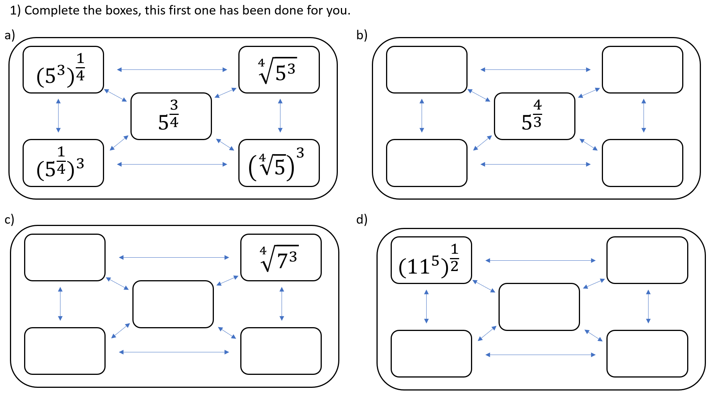 | Left to right, top to bottom  $${\left(5^{4}\right)}^{\frac{1}{3}}, {\left(\sqrt[3]{5}\right)}^{4}, {\left(5^{\frac{1}{3}}\right)}^{4}, \sqrt[3]{5^{4}},$$
$${\left(7^{3}\right)}^{\frac{1}{4}}, 7^{\frac{3}{4}}, {\left(7^{\frac{1}{4}}\right)}^{3}, {\left(\sqrt[4]{7}\right)}^{3}$$ | $$\sqrt{{11}^{5}}, {11}^{\frac{5}{2}}, {\left({11}^{\frac{1}{2}}\right)}^{5}, {\left(\sqrt{11}\right)}^{5}$$
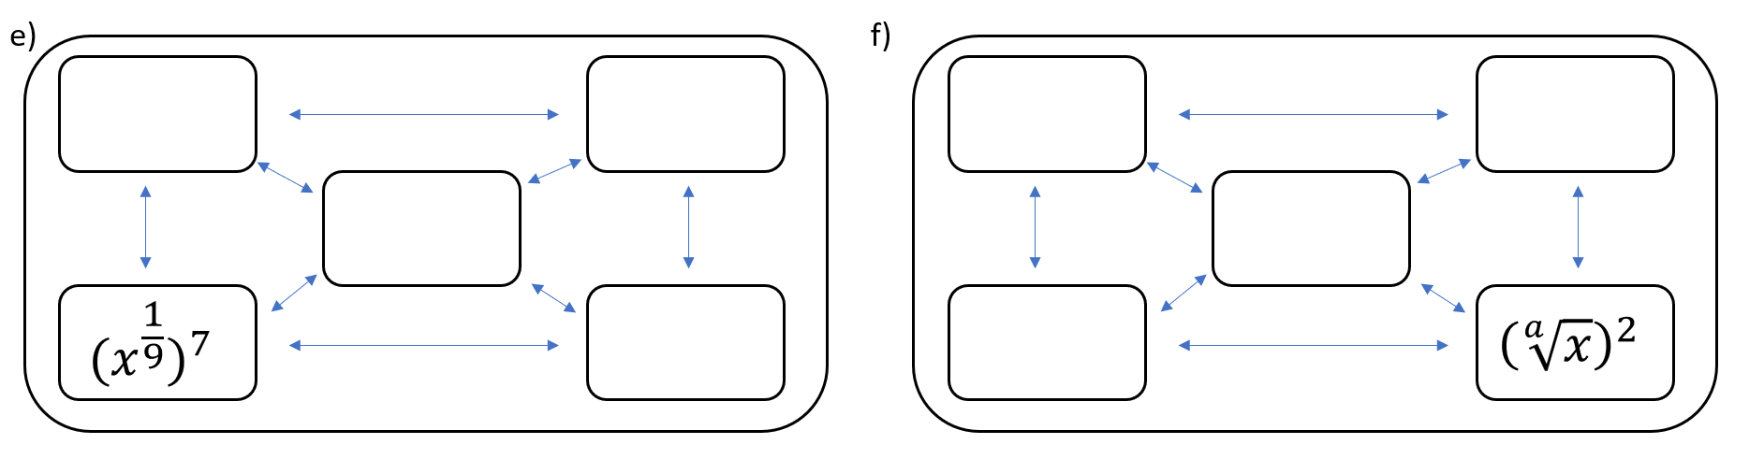  $${\left(x^{7}\right)}^{\frac{1}{9}}, \sqrt[9]{x^{7}}, x^{\frac{7}{9}}, {\left(x^{7}\right)}^{\frac{1}{9}}$$ | $${\left(x^{2}\right)}^{\frac{1}{a}}, \sqrt[9]{x^{2}}, x^{\frac{2}{9}}, {\left(x^{\frac{1}{9}}\right)}^{2}$$

Index Laws and Surd Laws

- Index Laws and Surd Laws
- As surds can be written with fractional indices, all index laws apply when working with surds.
- When changing numbers from index form to surd form, deal with negative indices first.

- Example Apply index laws to surds
$\sqrt{x^{5}y^{3}}$  $$={\left(x^{5}y^{3}\right)}^{\frac{1}{2}}$$  $$=x^{\frac{5}{2}}y^{\frac{3}{2}}$$ | $$\frac{1}{\sqrt[3]{x^{2}}}$$  $$=\frac{1}{x^{\frac{2}{3}}}$$  $$=x^{-\frac{2}{3}}$$

- Guided Practice
Write in index form.
- $\sqrt[5]{3t^{2}}$ | - $x\sqrt[3]{x}$ | - $2\sqrt[4]{y^{12}}$
- $\sqrt{3x^{2}}$ | - $\sqrt[3]{27t^{12}}$ | - $\frac{2}{3\sqrt{x^{5}}}$

Foundation
- Write the following with fractional indices.
- $\sqrt[5]{10t^{2}}$  $${10}^{\frac{1}{5}}t^{\frac{2}{5}}$$ | - $\sqrt[8]{8m^{4}}$  $$8^{\frac{1}{8}}m^{\frac{1}{2}}$$ | - $\sqrt[4]{7x^{7}}$  $$7^{\frac{1}{4}}x^{\frac{7}{4}}$$
- $6\sqrt{5}$  $$6×5^{\frac{1}{2}}$$ | - $7\sqrt{6}$  $$7×6^{\frac{1}{2}}$$ | - $5\sqrt[3]{4}$  $$5×4^{\frac{1}{3}}$$
- $7\sqrt{x^{5}}$  $$7x^{\frac{5}{2}}$$ | - $6\sqrt[3]{n^{7}}$  $$6n^{\frac{7}{3}}$$ | - $3\sqrt[4]{y^{12}}$  $$3y^{3}$$
- $5\sqrt[3]{p^{2}r}$  $$5p^{\frac{2}{3}}r^{\frac{1}{3}}$$ | - $2\sqrt[3]{a^{4}b^{2}}$  $$2a^{\frac{4}{3}}b^{\frac{2}{3}}$$ | - $2\sqrt[4]{g^{3}h^{5}}$  $$2g^{\frac{3}{4}}h^{\frac{5}{4}}$$

- Write the following in surd form.
- $x^{\frac{3}{4}}$  $$\sqrt[4]{x^{3}}$$ | - $x^{\frac{4}{3}}$  $$\sqrt[3]{x^{4}}$$ | - $x^{-\frac{4}{3}}$  $$\frac{1}{\sqrt[3]{x^{4}}}$$
- $2x^{\frac{1}{5}}$  2$\sqrt[5]{x}$ | - ${\left(2x\right)}^{\frac{1}{5}}$  $$\sqrt[5]{2x}$$ | - $x^{-\frac{7}{5}}y^{\frac{1}{5}}$  $$\frac{\sqrt[5]{y}}{\sqrt[5]{x^{7}}}$$

- Express in surd form.
- ${\left(64x^{3}\right)}^{\frac{1}{3}}$  $$4x$$ | - ${\left(64x\right)}^{-\frac{1}{2}}$  $$\frac{1}{8\sqrt{x}}$$ | - ${\left(64x^{\frac{1}{3}}\right)}^{\frac{1}{2}}$  $$8 \sqrt[6]{x}$$
- ${\left(64x\right)}^{\frac{1}{3}}$  $$4 \sqrt[3]{x}$$ | - $64x^{-\frac{1}{2}}$  $$\frac{64}{\sqrt{x}}$$ | - ${\left(64x^{\frac{1}{2}}\right)}^{\frac{1}{3}}$  $$4 \sqrt[6]{x}$$
- $64x^{\frac{1}{3}}$  $$64 \sqrt[3]{x}$$ | - $64x^{\frac{1}{2}}$  $$64\sqrt{x}$$ | - ${\left(64x^{3}\right)}^{\frac{1}{6}}$  $$2\sqrt{x}$$
- $64x^{-\frac{1}{3}}$  $$\frac{64}{\sqrt[3]{x}}$$ | - ${\left(64x^{\frac{1}{2}}\right)}^{3}$  $${64}^{3}\sqrt{x^{3}}$$ | - ${64\left(x^{2}\right)}^{\frac{1}{6}}$  $$64 \sqrt[3]{x}$$
- ${\left(64x\right)}^{-\frac{1}{3}}$  $$\frac{1}{4 \sqrt[3]{x}}$$ | - ${\left(64x^{3}\right)}^{\frac{1}{2}}$  $$8\sqrt{x^{3}}$$ | - ${\left(64x^{\frac{1}{3}}\right)}^{6}$  $${64}^{6}x^{2}$$

Development
- Fully simplify the following.
- $\sqrt{25s^{4}}$  $$5s^{2}$$ | - $\sqrt[3]{27t^{6}}$  $$3t^{2}$$ | - $\sqrt[4]{16t^{8}}$  $$2t^{2}$$
- $\sqrt[3]{125t^{12}}$  $$5t^{4}$$ | - ${\left(x^{3}\right)}^{\frac{1}{3}}$  $$x$$ | - ${\left(b^{12}\right)}^{\frac{1}{3}}$  $$b^{4}$$
- ${\left(16a^{2}b^{8}\right)}^{\frac{1}{2}}$  $$4ab^{4}$$ | - ${\left(32x^{10}y^{15}\right)}^{\frac{1}{5}}$  $$2x^{2}y^{3}$$ | - $\sqrt[3]{\frac{8x^{3}}{27}}$  $$\frac{2x}{3}$$

- Write without negative or fraction powers.
- $x^{-3}$  $$\frac{1}{x^{3}}$$ | - $3x^{-1}$  $$\frac{3}{x}$$ | - ${\left(3x\right)}^{-1}$  $$\frac{1}{3x}$$ | - $5x^{-2}$  $$\frac{5}{x^{2}}$$
- $\frac{2}{3}x^{-4}$  $$\frac{2}{3x^{4}}$$ | - $\frac{4}{5}x^{-3}$  $$\frac{4}{5x^{3}}$$ | - $\frac{4x^{-3}}{5}$  $$\frac{4}{5x^{3}}$$ | - $\frac{1}{5}x^{-3}$  $$\frac{1}{5x^{3}}$$
- $\frac{x^{-3}}{5}$  $$\frac{1}{5x^{3}}$$ | - $x^{\frac{1}{2}}$  $$\sqrt{x}$$ | - $x^{\frac{3}{2}}$  $$\sqrt{x^{3}}$$ | - $3x^{\frac{5}{2}}$  $$3\sqrt{x^{5}}$$
- $x^{-\frac{1}{2}}$  $$\frac{1}{\sqrt{x}}$$ | - $x^{-\frac{3}{4}}$  $$\frac{1}{\sqrt[4]{x^{3}}}$$ | - $3x^{-\frac{2}{3}}$  $$\frac{3}{\sqrt[3]{x^{2}}}$$ | - $\frac{1}{6}x^{-\frac{3}{4}}$  $$\frac{1}{6 \sqrt[4]{x^{3}}}$$

- Simplify the expression ${\left(3a\right)}^{-1}×3a^{-1}$

$$\frac{1}{a^{2}}$$
- NAPLAN A
What is the value of $p$ so that $\frac{a^{2}a^{-3}}{\sqrt{a}}=$ $a^{p}$

$$p=-1.5$$

- Write without roots, and if $x$ is in the denominator, as a negative power.
- $\frac{4}{x}$  $$4x^{-1}$$ | - $\frac{4}{x^{2}}$  $$4x^{-2}$$ | - $\frac{3}{4x^{2}}$  $$\frac{3x^{-2}}{4}$$ | - $\frac{1}{4x^{2}}$  $$\frac{x^{-2}}{4}$$
- $\frac{5}{x^{3}}$  $$5x^{-3}$$ | - $\sqrt{x}$  $$x^{\frac{1}{2}}$$ | - $\sqrt[3]{x}$  $$x^{\frac{1}{3}}$$ | - $\sqrt[3]{x^{2}}$  $$x^{\frac{2}{3}}$$
- $5\sqrt{x^{3}}$  $$5x^{\frac{3}{2}}$$ | - $\sqrt[5]{x^{3}}$  $$x^{\frac{3}{5}}$$ | - $\frac{1}{\sqrt{x}}$  $$x^{-\frac{1}{2}}$$ | - $\frac{1}{\sqrt[4]{x}}$  $$x^{-\frac{1}{4}}$$
- $\frac{4}{\sqrt[3]{x^{2}}}$  $$4x^{-\frac{2}{3}}$$ | - $\frac{2}{3\sqrt{x}}$  $$\frac{2x^{-\frac{1}{2}}}{3}$$ | - $\frac{1}{4 \sqrt[3]{x^{2}} }$  $$\frac{x^{-\frac{2}{3}}}{4}$$ | - $\frac{4}{5\sqrt{x^{3}}}$  $$\frac{4x^{-\frac{3}{2}}}{5}$$

- Evaluate without a calculator.
- $5^{0}$  1 | - ${49}^{\frac{1}{2}}$  7 | - ${125}^{\frac{1}{3}}$  5 | - $8^{\frac{2}{3}}$  4
- ${\left(9^{3}\right)}^{\frac{1}{2}}$  27 | - ${\left(\frac{125}{64}\right)}^{\frac{2}{3}}$  $$\frac{25}{16}$$ | - ${\left(-8\right)}^{\frac{2}{3}}$  4 | - $9^{-\frac{1}{2}}$  $$\frac{1}{3}$$
- $5^{-2}$  $$\frac{1}{25}$$ | - $\frac{1}{3^{-3}}$  27 | - ${\left(\frac{2}{5}\right)}^{-2}$  $$\frac{25}{4}$$ | - ${\left(\frac{1}{25}\right)}^{-\frac{3}{2}}$  125
- $4^{-\frac{1}{2}}$  $$\frac{1}{2}$$ | - ${125}^{-\frac{2}{3}}$  $$\frac{1}{25}$$ | - $8^{-3}×2^{8}$  $$\frac{1}{2}$$

Mastery
- Write in index form with a single base.
- $x^{2} \sqrt{x}$  $$x^{\frac{5}{2}}$$ | - $\frac{\sqrt{x}}{x^{3}}$  $$x^{-\frac{5}{2}}$$ | - $x^{3} \sqrt[3]{x^{2}}$  $$x^{\frac{11}{3}}$$ | - $\frac{x}{\sqrt[3]{x^{2}}}$  $$x^{\frac{1}{3}}$$
- $2\sqrt{2}$  $$2^{\frac{3}{2}}$$ | - $3\sqrt{3}$  $$3^{\frac{3}{2}}$$ | - $25\sqrt{5}$  $$5^{\frac{5}{2}}$$ | - $27\sqrt{3}$  $$3^{\frac{7}{2}}$$

- Use index laws to simplify these expressions. Answer in surd form.
$$a$$ | $$\sqrt[3]{a^{2}}$$ | $$a^{2}$$ | $$\sqrt{a^{5}}$$
$$\sqrt[3]{x}$$ | $$x$$ | $$\sqrt[6]{x^{5}}$$ | $$x$$
$$y$$ | $$y^{2}$$ | $$\sqrt{y^{3}}$$ | $$\sqrt[4]{x}$$
$$\sqrt[3]{x^{8}}$$ | $$\sqrt{a^{15}}$$ | $$\sqrt[8]{a^{3}}$$ | $$\sqrt[3]{n^{4}}$$
$$\sqrt[3]{a^{4}}$$ | $$\sqrt[10]{a^{7}}$$ | $$\sqrt[21]{a^{23}}$$ | $$\sqrt[3]{a^{8}}$$

- Simplify the following using index laws. Write your answer without fractional or negative indices.
- $x^{3}×x$  $$x^{4}$$ | - $x^{2}×\sqrt[3]{x}$  $$x^{\frac{7}{3}}=\sqrt[3]{x^{7}}$$ | - $\frac{1}{x}×\frac{1}{x}$  $$x^{-2}=\frac{1}{x^{2}}$$ | - $\frac{2}{\sqrt{x}}×\sqrt{x}$  $$2$$
- $\sqrt{x}×\sqrt{x}$  $$x$$ | - $\sqrt{x}×\sqrt[3]{x}$  $$x^{\frac{5}{6}}=\sqrt[6]{x^{5}}$$ | - $\frac{1}{x}×x$  $$1$$ | - $\frac{1}{\sqrt{x}}×x$  $$\sqrt{x}$$
- $x^{2}×\sqrt{x}$  $$x^{\frac{5}{2}}=\sqrt{x^{5}}$$ | - $x\sqrt{x}×x$  $$x^{\frac{5}{2}}=\sqrt{x^{5}}$$ | - $\frac{3}{x}×x$  $$3$$ | - $\frac{1}{\sqrt{x}}×\frac{x}{\sqrt{x}}$  1
- $x^{3}×\sqrt{x}$  $$x^{\frac{7}{2}}=\sqrt{x^{7}}$$ | - $x\sqrt{x}×x\sqrt{x}$  $$x^{3}$$ | - $\frac{1}{\sqrt{x}}×\frac{1}{\sqrt{x}}$  $$x^{-1}=\frac{1}{x}$$ | - $\frac{x^{2}}{\sqrt{x}}×\frac{\sqrt{x}}{x\sqrt{x}}$  $$\sqrt{x}$$

- Expand these expressions. Write your final answer without indices.
- ${\left(x^{\frac{1}{2}}+x^{-\frac{1}{2}}\right)}^{2}$  $$x+2+\frac{1}{x}$$ | - ${\left(x^{\frac{1}{2}}-x^{-\frac{1}{2}}\right)}^{2}$  $$x-2+\frac{1}{x}$$ | - ${\left(x^{\frac{5}{2}}-x^{-\frac{5}{2}}\right)}^{2}$  $$x^{5}-2+\frac{1}{x^{5}}$$
- ${\left(x+5x^{-1}\right)}^{2}$  $$x^{2}+10+\frac{25}{x^{2}}$$ | - ${\left(x^{2}-7x^{-2}\right)}^{2}$  $$x^{4}-14+\frac{49}{x^{4}}$$ | - ${\left(3x^{\frac{1}{2}}-2x^{-\frac{1}{2}}\right)}^{2}$  $$9x-12+\frac{4}{x}$$

- Write the following in index form.
- $\sqrt{2\sqrt{2}}$  $$={\left(2\sqrt{2}\right)}^{\frac{1}{2}}$$  $$={\left(2^{1}×2^{\frac{1}{2}}\right)}^{\frac{1}{2}}$$  $$=$$  $$2^{\frac{3}{4}}$$ | - $\sqrt{2\sqrt{2\sqrt{2} }}$  $$2^{\frac{7}{8}}$$ | - $\sqrt{2\sqrt{2\sqrt{2\sqrt{2}}}}$  $$2^{\frac{15}{16}}$$
  - What do you notice?
The fractional index has denominator of $2^{n}$ where $n$ is the number of twos, and numerator is $2^{n}-1$
  - What would be $\sqrt{2\sqrt{2\sqrt{2 \sqrt{2}}}… }$ with 6 twos?
Answer in index form and check your answer using a calculator.

$$2^{\frac{63}{64}}$$
  - What would be $\sqrt{2\sqrt{2\sqrt{2 \sqrt{2}}}… }$ with $n$ twos? Answer in index form.

$$2^{\frac{2^{n-1}}{2^{n}}}$$

Exponential Equations

- Exponential Equations
- Exponential equations involve finding the value of a pronumeral in the index.
- For example: $2^{x}=8$ and $3^{2x}-3^{x}-6=0$.
- To solve exponential equations:
- Rewrite all terms with the smallest possible base number.
- Write an equation using the powers.

- Example Solve exponential equations
$${25}^{x}=125$$1. $5^{2x}=5^{3}$2. $2x=3$ $x=$ $\frac{3}{2}$ | $$3^{x}=\frac{1}{9}$$1. $3^{x}=$ $\frac{1}{3^{2}}$ $3^{x}=3^{-2}$2. $x=-2$

- Guided Practice
- $9^{x}=27$  $3^{}=3^{}$  $$x=\frac{3}{2}$$ | - $2^{x}=$ $\frac{1}{8}$  $$x=-3$$ | - ${16}^{x}=64$  $$x=\frac{3}{2}$$

- Example Solve exponential equations with binomial powers
$$9^{2x-1}=27$$1. ${\left(3^{2}\right)}^{2x-1}=3^{3}$ $3^{4x-2}=3^{3}$2. $4x-2=3$ $4x=5$ $x=$ $\frac{5}{4}$

- Guided Practice
- ${25}^{x+3}=125$  $$x=-\frac{3}{2}$$ | - ${27}^{x+3}=9^{2x}$  $$x=9$$

Foundation
- Solve for $x$.
- $3^{x}=27$  3 | - $2^{x}=32$  5 | - $4^{x}=64$  3 | - ${10}^{x}=10 000$  4

- Solve for $x$.
- $7^{x}=$ $\frac{1}{49}$  $$-2$$ | - ${11}^{x}=$ $\frac{1}{121}$  $$-2$$ | - $3^{x}=$ $\frac{1}{243}$  $$-5$$
- $3^{-x}=$ $\frac{1}{3}$  $$1$$ | - $2^{-x}=64$  $$-6$$ | - $7^{-x}=$ $\frac{1}{343}$  $$3$$

- Solve for $x$.
- $8^{x}=16$  $$\frac{4}{3}$$ | - ${25}^{x}=125$  $$\frac{3}{2}$$ | - ${81}^{x}=9$  $$\frac{1}{2}$$
- ${32}^{x}=2$  $$\frac{1}{5}$$ | - ${10000}^{x}=10$  $$\frac{1}{4}$$ | - $7^{-x}=49$  $$-2$$
- $4^{-x}=256$  $$-4$$ | - ${16}^{-x}=64$  $$-\frac{3}{2}$$ | - ${25}^{-x}=125$  $$-\frac{3}{2}$$

- Solve for $x$.
- ${\left(\frac{3}{4}\right)}^{x}=\frac{4}{3}$  $$-1$$ | - ${\left(\frac{2}{3}\right)}^{x}=\frac{9}{4}$  $$-2$$ | - ${\left(\frac{2}{5}\right)}^{x}=\frac{125}{8}$  $$-3$$
- $\frac{1}{2^{x}}$ $=8$  $$-3$$ | - $\frac{1}{3^{x}}$ $=81$  $$-4$$ | - $\frac{1}{2^{x}}$ $=1$  0

- Solve for $x$.
- $7^{x+9}=49$  $$-7$$ | - $2^{x+1}=8^{x}$  $$\frac{1}{2}$$ | - $9^{x+12}={81}^{x+5}$  $$2$$
- ${27}^{x+3}=9^{2x}$  9 | - ${32}^{2x+3}={128}^{2x}$  $$\frac{15}{4}$$ | - ${25}^{x+3}={125}^{3x}$  $$\frac{6}{7}$$
- ${27}^{2x+3}=9^{2x-1}$  $$-\frac{11}{2}$$ | - $9^{x-1}={27}^{2x-6}$  4 | - ${49}^{2x-3}={343}^{2x-1}$  $$-\frac{3}{2}$$
- $6^{2n-6}=1$  3 | - ${11}^{3n-1}=11$  $$\frac{2}{3}$$ | - $8^{5n-1}=$ $\frac{1}{2}$  $$\frac{2}{15}$$

- Solve for $x$.
- $3^{x}=\sqrt{81}$  2 | - $6^{x}=\sqrt[3]{36}$  $$\frac{2}{3}$$ | - $4^{x}=\sqrt[4]{64}$  $$\frac{3}{4}$$
- $3^{x}=\sqrt[9]{27}$  $$\frac{1}{3}$$ | - ${25}^{x}=\sqrt[5]{125}$  $$\frac{3}{10}$$ | - $9^{x}=$ $\frac{1}{\sqrt[3]{27} }$  $$-\frac{1}{2}$$

Development
- Find the value of $x$ in these equations.
- ${\left(\frac{1}{3}\right)}^{x}=\frac{1}{81}$  4 | - ${\left(\frac{1}{3}\right)}^{x}=81$  $$-4$$ | - ${\left(\frac{1}{3}\right)}^{x}=27$  $$-3$$ | - ${\left(\frac{1}{3}\right)}^{x}=\frac{1}{27}$  3
- ${\left(\frac{1}{4}\right)}^{x}=64$  $$-3$$ | - ${\left(\frac{1}{4}\right)}^{x}=256$  $$-4$$ | - ${\left(\frac{1}{4}\right)}^{x}=\frac{1}{256}$  4 | - ${\left(\frac{5}{25}\right)}^{x}=625$  $$-4$$

- Solve for $x$
- $5^{x-1}=$ $\frac{1}{25}$  $$-1$$ | - $3^{x-3}=$ $\frac{1}{9}$  1 | - ${10}^{x-5}=$ $\frac{1}{1000}$  2
- ${\left(\frac{3}{4}\right)}^{2x+1}=\frac{64}{27}$  $$-2$$ | - ${\left(\frac{2}{5}\right)}^{3x-5}=\frac{25}{4}$  $$1$$ | - ${\left(\frac{3}{2}\right)}^{3x+2}=\frac{16}{81}$  $$-2$$
- ${\left(\frac{7}{4}\right)}^{1-x}=\frac{4}{7}$  $$2$$ | - $3^{2x-1}=$ $\frac{1}{81}$  $$-\frac{3}{2}$$ | - $7^{2x+3}=$ $\frac{1}{49}$  $$-\frac{5}{2}$$

- Solve $2^{3x-3}=8^{2-x}$.

$$\frac{3}{2}$$
- Solve $3^{-4x}=9^{6-x}$.

$$-6$$
- Solve for $x$. Rewrite the decimals as fractions.
- ${10}^{x}=0.0001$  $$-4$$ | - $2^{x}=0.125$  $$-3$$ | - $5^{x}=$ $0.00032$  $$-5$$
- ${\left(0.25\right)}^{x}=0.5$  0.5 | - ${\left(0.04\right)}^{x}=125$  $$-1.5$$ | - ${\left(0.0625\right)}^{x+1}=$ $\frac{1}{2}$  $$-\frac{3}{4}$$

- Solve for $x$.
- $3^{x}×9^{x}=27$  1 | - $5^{3x}×{25}^{-2x+1}=125$  $$-1$$ | - $2^{-3x}×4^{2x-2}=16$  $$8$$
- ${16}^{-x}=$ $\frac{1}{32}$  $$\frac{5}{4}$$ | - $8^{x}=4^{x+1}$  $$2$$ | - ${16}^{2-x}=$ $\frac{1}{8^{x}}$  $$8$$
- $\frac{3^{n-2}}{9^{1-n}}$ $=9$  2 | - $\frac{5^{3n-3}}{{25}^{n-3}}$ $=125$  0 | - $\frac{{36}^{3+2n}}{6^{n}}$ $=1$  $$-2$$

- Solve for $x$
$${\left(\frac{1}{5}\right)}^{x+1}={\left(\frac{1}{125}\right)}^{x-1}$$  $$2$$ | $$\sqrt{2^{4x}×4^{2x}×8^{4x}}={256}^{x}$$  0

Mastery
- Solve these exponential equations.
- $2^{x}=128$  7 | - $3^{x}=$ $\frac{1}{3}$  $$-1$$ | - ${15}^{y}=\sqrt{15}$  $$\frac{1}{2}$$
- ${15}^{y}=$ $\frac{1}{\sqrt{15}}$  $$-\frac{1}{2}$$ | - $7^{k}=7\sqrt{7}$  $$\frac{3}{2}$$ | - $5^{x}=0.2$  $$-1$$
- ${49}^{k}=7$  $$\frac{1}{2}$$ | - $3^{x}=\sqrt[3]{9}$  $$\frac{2}{3}$$ | - ${25}^{k}=125$  $$\frac{3}{2}$$
- $7^{x}=$ $\frac{1}{\sqrt{7}}$  $$-\frac{1}{2}$$ | - $6^{k}=6\sqrt{6}$  $$\frac{3}{2}$$ | - ${121}^{y}×\sqrt[3]{11}=1331$  $$\frac{4}{3}$$
- ${\left(3^{8}\right)}^{\frac{1}{2}}=3^{m}$  4 | - $2^{k-4}=1$  4 | - $2^{5-2x}=$ $\frac{1}{4}$  $$\frac{7}{2}$$
- $\frac{\sqrt[3]{5}}{5}=5^{m}$  $$-\frac{2}{3}$$ | - ${\left(\frac{1}{3}\right)}^{x+1}=27$  $$-4$$ | - ${\left(\frac{1}{36}\right)}^{5k+8}=216$  $$-\frac{19}{10}$$
- ${10}^{y}×{100}^{y}=0.001$  $$-1$$ | - ${\left(\frac{1}{8}\right)}^{1-2k}$ $={128}^{k}$  $$-3$$ | - ${\left(\frac{25}{\sqrt[3]{5}}\right)}^{\frac{x}{2}}=5$  $$\frac{6}{5}$$
- $1000=$ $\frac{{100}^{n}}{\sqrt[5]{{10}^{n}}}$  $$\frac{5}{3}$$ | - $\frac{9^{y}}{{27}^{5-y}}$ $=\sqrt{243}$  $$\frac{7}{2}$$ | - $\frac{\sqrt[3]{5^{m}}}{\sqrt{5}}$ $={25}^{4}$  $$\frac{51}{2}$$

- Solve simultaneously:
- $7^{2x-y}=49$  $2^{x+y}=128$  $$x=3. y=4$$ | - $8^{x}÷4^{y}=4$  $${11}^{y-x}=\frac{1}{11}$$  $$x=0, y=-1$$
- ${13}^{x+4y}=1$  ${25}^{x+5y}=5$  $$x=-2, y=\frac{1}{2}$$ | - $2^{a}+3^{b}=17$  $2^{a+1}-3^{b+1}=-11$  $$a=3, b=2$$

Factorising Expressions with Indices

- Factorising Expressions with Indices
- We can split a base based on prime factors.
This allows us to simplify when the bases aren’t the same.

- Example Simplify expressions with indices by factorisation
$$6×2^{n}$$  $$=2×3×2^{n}$$  $$=2^{n+1}×3$$ | $${12}^{n}×9={\left(4×3\right)}^{n}×3^{2}$$  $=4^{n}×3^{n}×3^{2}$  $=2^{2n}×3^{n+2}$

- Guided Practice
Simplify by writing these expressions with prime bases.
- $2^{n}×4^{n}×8^{n}$  $$2^{6n}$$ | - ${18}^{n}×12$  $$2^{n+2}×3^{2n+1}$$
- ${100}^{2n-1}×{25}^{-1}×8^{-1}$  $$2^{4n-5}×5^{4n-4}$$ | - $\frac{9^{n+2}×3^{n+1}}{3×{27}^{n}}$  81

- Factorising Expressions with Indices
- We can factorise expressions involving addition and subtraction by taking out a common factor. This is useful when simplifying fractions.

- Example Simplify expressions with indices by factorisation
$$5^{n}+5^{n+2}$$  $$=5^{n}\left(1+5^{2}\right)$$  $$=5^{n}×26$$ | $$=3^{n}+3^{n+1}$$  $$=3^{n}+3×3^{n} \\ =3^{n}\left(1+3\right) \\ =4×3^{n}$$

- Guided Practice
Simplify by factorising.
- $7^{n+2}+7^{n}$  $$50×7^{n}$$ | - $4^{n}+{12}^{n}$  $$4^{n}\left(1+3^{n}\right) or 2^{2n}\left(1+3^{n}\right)$$
- $2^{2n+2}-2^{2n-1}$  $$7×2^{2n-1} or 3.5×2^{2n}$$ | - $\frac{3^{n+3}-3^{n}}{3^{n}}$  26

Foundation
- Simplify by making all the bases the same.
- $3×3^{x}$  $$3^{x+1}$$ | - $32×2^{x}$  $$2^{x+5}$$ | - $\frac{1}{2}×2^{x}$  $$2^{x-1}$$
- $5^{2x}×5^{3x}÷{25}^{x}$  $$5^{3x}$$ | - $7^{3x+4}÷{49}^{9-3x}$  $$7^{9x-14}$$ | - ${\left(9^{x}\right)}^{2}×{\left(3^{3x}\right)}^{3}$  $$3^{13x}$$
- $8^{2x}÷2^{6x}×4^{x}$  $$2^{2x}$$ | - $9^{3m+1}×3^{4m-1}$  $$3^{10m+1}$$ | - ${32}^{n}÷8^{2n}÷4^{3n}$  $$2^{-7n}$$
- $6^{x}×4^{x}÷3^{x}$  $$2^{3x}$$ | - ${12}^{x}×{18}^{x}$  $$2^{3x}×3^{3x}$$ | - ${24}^{x+1}×8^{-1}$  $$3^{x+1}×2^{3x}$$

- Simplify by factorising each base to the smallest prime factors.
- $\frac{2^{n}×9^{2n+1}}{6^{n-2}}$  $$=\frac{2^{n}×3^{4n+2}}{2^{n-2}×3^{n-2}}$$  $=$  $$2^{2}×3^{3n+4}$$ | - $\frac{{25}^{3n}×5^{n-3}}{5^{4n+3}}$  $$5^{3n-6}$$ | - $\frac{{12}^{x-2}×4^{x}}{6^{x-2}}$  $$2^{3x-2}$$
- $\frac{{12}^{n-3}×{27}^{1-n}}{9^{2n}×8^{n-1}×{16}^{n}}$  $$2^{-5n-3}×3^{-6n}$$ | - $\frac{4^{n}×7^{n-3}×{49}^{3n+1}}{{14}^{n+2}}$  $$2^{n-2}×7^{6n-3}$$ | - $\frac{{35}^{2}×5^{2}×7^{6}}{{25}^{4}×{49}^{3}}$  $$\frac{49}{625}$$

Development

  - Simplify $2×2^{x}$
  - Hence explain why $2^{x}+2^{x}$ can be written as $2^{x+1}$
$$2^{x}+2^{x}=2×2^{x}=2^{x+1}$$
  - What is the highest common factor of these two terms: $2^{x+1}$ and $2^{x}$
$$2^{x}$$
  - Therefore, factorise $2^{x+1}+2^{x}$ by taking out the highest common factor.
$$2^{x}\left(2+1\right)=3\left(2^{x}\right)$$
Factorise the following by factoring out a common factor.
- $3^{x}+3^{x}+3^{x}$  $$3^{x+1}$$ | - $3^{8}-3^{7}$  $$2×3^{7}$$ | - $3^{n}+3^{n+1}$  $$4×3^{n}$$
- $\frac{7^{n} + 7^{n+2}}{7^{n-1} + 7^{n+1}}$  7 | - $\frac{2^{2n} - 2^{n-1}}{2^{n} - 2^{-1}}$  $$2^{n}$$ | - $\frac{5^{n} - 5^{n+1}}{5^{n+1} + 5^{n}}$  $$-\frac{2}{3}$$
- $5^{n}-5^{n-3}$  $$124×5^{n-3}$$ | - $\frac{7^{n}+7^{n+2}}{7^{n-1}+7^{n+1}}$  $$7$$ | - $\frac{2^{2n}-2^{n-1}}{2^{n}-2^{-1}}$  $$2^{n}$$
- $\frac{2^{n+3}-4×2^{n}}{2^{2n}-4^{n-1}}$  $$\frac{16}{3×2^{n}}$$ | - $\frac{2^{n+1}}{{\left(2^{n}\right)}^{n+1}}÷\frac{{\left(2^{2n+1}\right)}^{n-1}}{4^{n}}$  $$2^{-3n^{2}+3n+2}$$ | - $\frac{a^{2}x^{m}-b^{2}x^{m+4}}{a-bx^{2}}$  $$x^{m}\left(a+bx^{2}\right)$$
- Simplify by a combination of prime factorisation and taking out a common factor.
- $6^{n}-3^{n}$  $$3^{n}\left(2^{n}-1\right)$$ | - $\frac{6^{n}+3^{n}}{2^{n+1}+2}$  $$\frac{3^{n}}{2}$$ | - $\frac{{12}^{x}+1}{6^{2x}+3^{x}}$  $$\frac{1}{3^{x}}$$ | - $\frac{{12}^{n}-{18}^{n}}{3^{n}-2^{n}}$  $$-2^{n}3^{n}$$

  - Factorise $5^{n+1}+5^{n}$

  - Hence simplify $\frac{5^{101}+5^{100}}{6}$

$$5^{100}$$
- Find the value of $x$ if $2^{x}$ is half of $2^{200}$

199

Mastery
- Factorise and hence simplify the following. (hint: difference of two squares)
- $\frac{9^{n}-1}{3^{n}-1}$  $$\left(3^{n}+1\right)$$ | - $\frac{5^{2n}-5^{n}}{5^{n}-1}$  $$5^{n}$$

- Factorise: (hint: difference of two squares)
- $5^{2x}-2^{2y}$  $$\left(5^{x}+2^{y}\right)\left(5^{x}-2^{y}\right)$$ | - $2^{4x}-2^{6x}$  $$2^{4x}\left(1+2^{x}\right)\left(1-2^{x}\right)$$

- Solve
- $8^{x}=2^{x+3}+2^{x+3}$  2 | - ${32}^{x}=2^{x+5}-2^{x+4}$  1 | - $4^{x}-2^{x+1}-8=0$  2

- Simplify $6^{6}+6^{6}+6^{6}+6^{6}+6^{6}+6^{6}$ and express your answer in index form.

$$6^{7}$$
- Show that $2^{2m+3}+4^{m}$ is a multiple of 3 for all positive integers $m$.

$2^{2m+3}+4^{m}=9\left(2^{2m}\right);∴$multiple of 3

